SCILT RESOURCES
A 1+2 Approach to Language Learning: Information for parents
The 1+2 parent leaflet will help to address any questions parents may have about the 1+2 approach to language learning. It will be really useful for parents’ evenings.
Parent leaflet: Inspiring Scotland’s young people to embrace language learning
The parent leaflet is to help inform parents of the wide range of benefits of learning a foreign language. They can be really useful for parents’ evenings and also for course choice events.
Literacy leaflet: Developing literacy through language learning: a guide for parents
This leaflet promotes the positive connections between language learning and literacy skills. This will be a useful tool for parents’ evenings and will be powerful in advocating the value of language learning to colleagues.
Entitlement leaflet: Making languages count for my child
This guide for parents aims to give you information about your child’s entitlement to language learning, answer common questions you might have about language learning and provide advice on how you can help your child understand the benefits of language learning

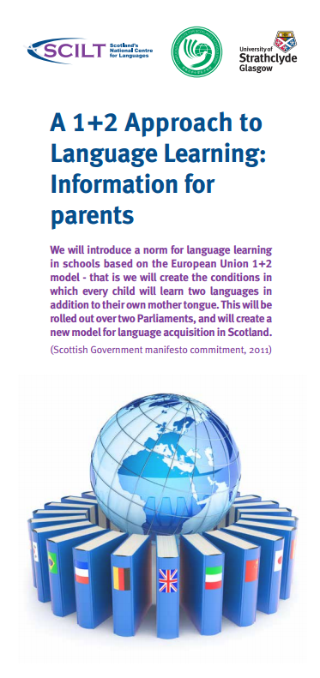
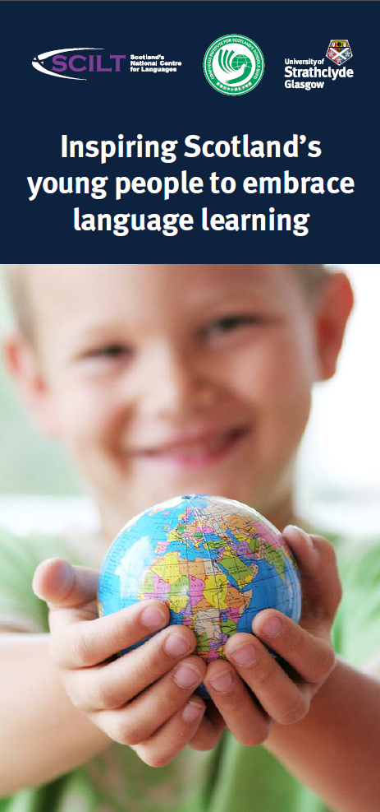
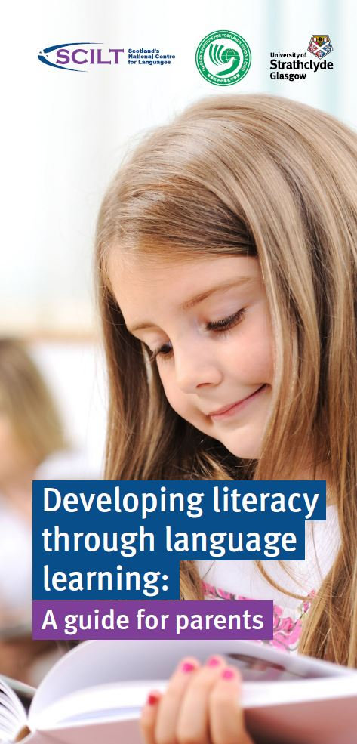
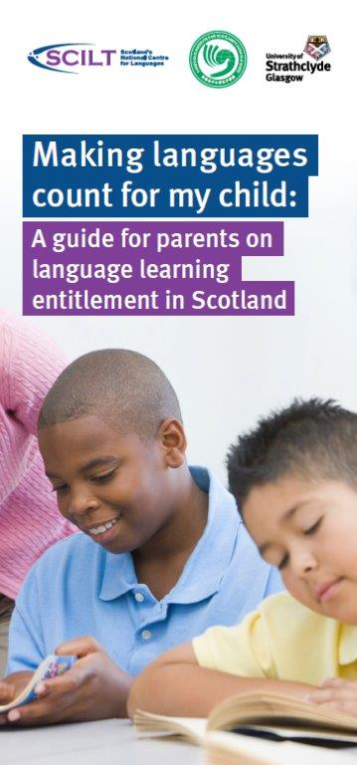
Bookmark: A little language goes a long, long way…
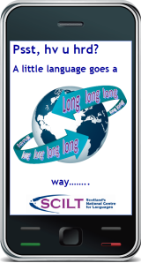
These promotional bookmarks are designed to show pupils why learning languages is beneficial in a light-hearted way. They could be really useful for rewarding and motivating your pupils.

Postcard: Thinking about continuing with languages when you leave school?
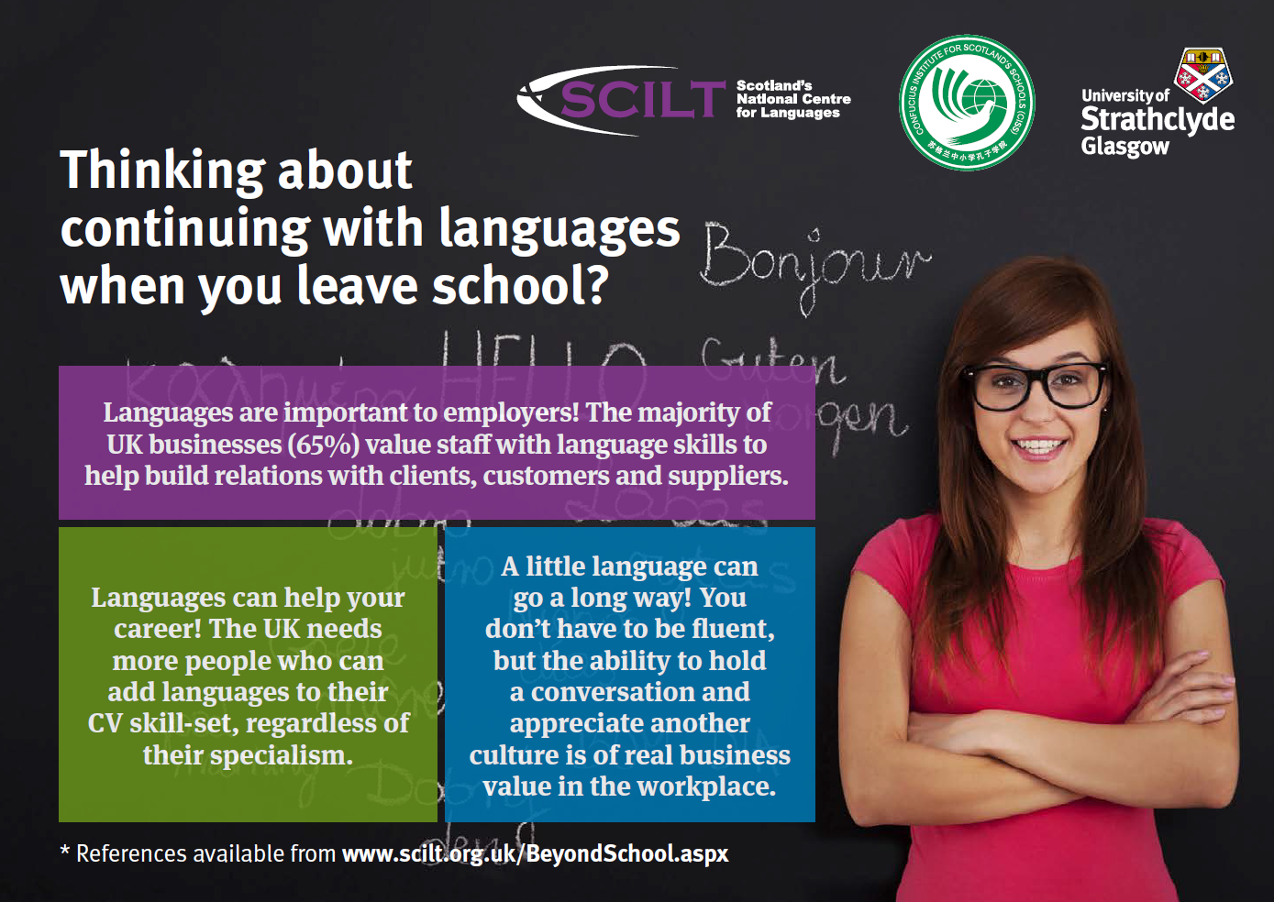
This postcard highlights the advantages of continuing language learning to complement future studies, whether at college or university, and to highlight the options available. It will be useful for supporting senior pupils make choices about their paths beyond school.

If you would be interested in ordering any of these materials, simply fill in the form and send it back to us. Although these products are free of charge, we would ask in return that you briefly explain how you intend to use them in your establishment.
Many thanks from the SCILT team!
ORDER FORM
Number of products required: | 1+2 Parent Leaflet: A 1+2 Approach to Language Learning: Information for parents | Parent leaflet: Inspiring Scotland’s young people to embrace language learning |  | Literacy leaflet:  Developing literacy through language learning: a guide for parents
Number of products required: | 50 leaflets □  100 leaflets □  150 leaflets □ | 50 leaflets □  100 leaflets □  150 leaflets □ |  | 50 leaflets □  100 leaflets □  150 leaflets □
 | Entitlement leaflet: Making languages count for my child: a guide for parents | Bookmark: A little language goes a long, long way… |  | Postcard: Thinking about continuing with languages
 | 50 leaflets □  100 leaflets □  150 leaflets □ | 50 bookmarks □  100 bookmarks □  150 bookmarks □ |  | 50 postcards □  100 postcards □  150 postcards □
Contact name: |  | Contact email:
School:
School Address:
Postcode:
Local Authority:
Form continues below
Please briefly explain how you intend to use these materials:

Please email the completed form to scilt@strath.ac.uk
Or send this completed form to:
SCILT, Scotland’s National Centre for Languages
Lord Hope Building, Room LH232
University of Strathclyde
Glasgow G4 0LT

