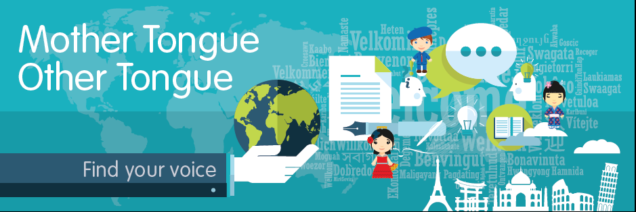

Mother Tongue Other Tongue
2018

Information Pack

What is Mother Tongue Other Tongue?

“Scotland is a country which is rich in diversity and institutions should celebrate the cultural and linguistic backgrounds of all learners.”
Education Scotland
Mother Tongue Other Tongue (MTOT) celebrates cultural diversity, promotes language learning and showcases the many languages which are spoken by young people in school/college/university and at home. MTOT is a multilingual poetry competition with two distinct categories:

Mother Tongue
Mother Tongue celebrates cultural diversity by encouraging non-native speakers of English/users of BSL to share lullabies, poems, songs and raps from their mother tongue language. Pieces can be submitted in any language other than English.

Other Tongue
Other Tongue promotes the learning of languages (including BSL) by giving children and young people the opportunity to use their language skills in a creative way. Learners are asked to submit an original poem, song, rhyme or rap written in the language that they are learning in school/college/uni as L2 or L3.

Why poetry?
Learning about and creating poetry can be an engaging and worthwhile way to learn languages. Through creative writing, learners may participate in activities that help them develop creative thinking skills like imagining, devising, brainstorming and seeing things in different ways. It may also give learners experiences that require them to use their language skills to adapt and manipulate the language for different purposes. With fewer worries about grammar and the opportunity to play with words and experiment with language, it may bring a sense of freedom and enjoyment to using the target language.
For younger learners, poetry can help language learning in that it lends itself well to repetition, exploration of sound, rhythm, rhyme and pattern. It gives more advanced learners the chance to explore more figurative language and to develop more complex ideas and thoughts.
Poetry can help in celebrating diversity too. Giving children and young people a chance to share their poems allows them to hear about others’ experiences and perspectives. A competition like Mother Tongue Other Tongue has the potential to help learners develop a global outlook through raising awareness of the multilingual world that exists around them.

General Advice (for schools)
In schools, where possible, teachers may build on work which is already being done. For example, linking poems to a topic area learners are studying will make the experience more meaningful for them, as well as improving the overall quality of their poems.
Teachers may find MTOT useful in supporting the following activities in school:
- Interdisciplinary learning projects
- National celebrations (read “Support for Schools”)
- Consolidating and extending work on existing units of work
- Developing creative approaches to transition
- Developing progressive learning experiences in a second additional language (L3)
- Building confidence through creative writing
- Developing intercultural understanding
- Developing critical thinking skills and skills of analysis
- Developing English skills for EAL learners
We encourage teachers to work on MTOT as part of their normal curriculum work within the mainstream classroom. For example, in a class writing poems for Remembrance Day, monolingual English-speaking learners could write their poems in Scots and bilingual learners could write in their home language – both can be submitted in the Mother Tongue category. Another example could be writing spooky Halloween poems by a class learning Spanish as L2. Learners could enter in the Other Tongue category or any bilingual learners could choose to write their poem in either Spanish (OT) or in their home language instead (MT). We really want to emphasise the links between languages and literacy across the curriculum and the interchangeable nature of the words/languages we choose to express ourselves in.

Competition Timeline

Register to take part | By 26 October 2018
Deadline for FE/HE to submit entries to co-ordinator  Deadline for all entries to SCILT | 3 December 2018  14 December 2018
Judging of entries | January 2019
Notification of successful entries sent out to institutions | February 2019
Publication of anthology and celebration event | 16 March 2019

Mother Tongue Other Tongue general rules and information:

MTOT is open to all learners in P1 to S6 and also FE/HE students. Categories are as follows:
P1-P3
P4-P6
P7-S1
S2-S3
Senior Phase
Further and Higher Education
- Entries may be submitted for individuals and/or groups (of up to four people maximum) of learners from same age category. However, in the first category, P1 – P3, learners may work together on a class poem.
- Institutions should hold in-house competitions to determine the best poems before submitting a maximum of 10 entries per school into the competition. (Read “Holding an in-house competition”)
- Entries and appendices should be scanned and submitted electronically by a teacher who will be the contact for the competition. In the body of the email, please state: name of teacher, name of school, total number of learners participating in competition at school level, total number of entries submitted and names of entrants.
- Each entry must be accompanied by the relevant cover sheet (appendix A). Entries received without a cover sheet cannot be judged.
- Learners may submit a video file accompanied by a transcript. (Read “Submitting a video clip”)
- If a bilingual learner wishes to submit a piece in one of the languages they speak, they should enter this into the Mother Tongue competition.
- Learners entering the Mother Tongue category may wish to use more than one language within the same poem, reflecting the nature of their multilingual heritage.

Mother Tongue competition guidelines:
Learners whose first language is not English are encouraged to take part in the Mother Tongue competition.
They should submit an original piece (poem, song or rap) by the learner(s) in their mother tongue (any language, inc. BSL, except English). Scots entries may be submitted in this category.
AND

A commentary of no more than 250 words written in English by the learner. Entries are judged on the basis of this commentary.

Guidelines for the Mother Tongue commentary:
The purpose of the English commentary is to evidence the process of creating a poem or responding personally to an existing piece of work.

- Entrants should write enough to allow them to develop their thoughts, feelings and ideas about the piece. The length of the commentary is likely to differ depending on the age and stage of the learner.
- Commentaries which elaborate on personal experiences, background knowledge, feelings or attitudes are more likely to be successful than those which offer very generic statements, e.g. “It’s funny”, “I like it”, etc.
- An entrant may make use of scribes, translators and other support as required to write their commentary in English, as long as ideas expressed are their own.
- Commentaries should avoid a simple re-telling of the poem. Where appropriate, learners should be encouraged to comment on the use of language, imagery, figurative language, historical context, themes and/or social/ cultural/ political relevance.
- Teachers should encourage learners to aim for accuracy in terms of spelling, grammar, syntax, etc.
- See reflective questions for support in writing a commentary (Appendix C)

Some examples of Mother Tongue commentaries from 2015-2016:

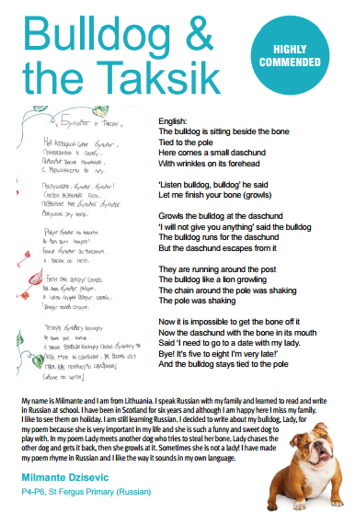

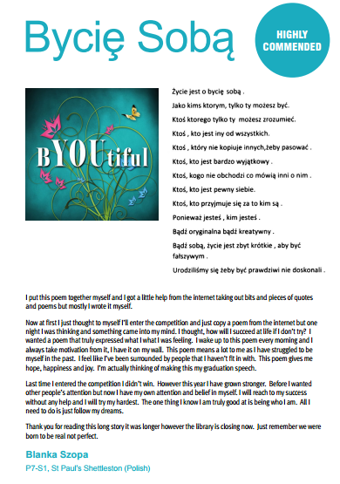

Other Tongue competition guidelines:
Any learner who is learning another language at school/college/university can take part in the Other Tongue competition.
- Entries must comprise an original poem, rhyme, rap or song created in a language that is not the first language - or one of the languages - spoken by the entrant.
- Pieces may be created in any of the following languages studied in the school/college/university: French, Spanish, German, Cantonese, Mandarin, BSL, Italian, Gaelic (Learners), Urdu.
- Pieces must be accompanied by a commentary of no more than 250 words written in English by the learner. Entries are judged on the basis of the poem and commentary combined.

Further guidelines for Other Tongue entrants:
- Teachers may support and/or guide entrants as they write poems, but poems must reflect entrants’ own work.
- It is acceptable for a similar approach to be used in a number of poems entered by the same centre, but entrants should be encouraged as far as possible to personalise their poems.
- Judges will be mindful of the fact that poems may play with language or use non-standard structures for effect. However, where it is obvious that there are errors and/or these detract from the overall effect, judges may take this into consideration.
- Entrants should write enough in the English commentary to allow them to develop their thoughts, feelings and ideas about their poem. The length of the commentary is likely to differ depending on the age and stage of entrants.
- The purpose of the English commentary is to evidence the entrant’s process of writing a poem in another language. The competition does not prescribe the content of the English commentaries, but the following suggestions may be helpful;
  - Reasons for choosing to write about a particular subject or particular themes
  - The thinking behind choice of words and/or use of figurative language
  - General feelings about the poem or the experience of writing a poem in another language
  - Details of any background research or knowledge into a theme/subject
- Teachers should encourage learners to aim for accuracy in terms of spelling, grammar, syntax, etc.
- See reflective questions for writing a commentary (Appendix C)

Holding an in-house competition:
- Institutions may submit a maximum of 10 entries into the competition. Therefore, teachers may wish to hold a class or year group heat to determine which poems will finally be submitted from the institution.
- SCILT would like to share any articles, photographs or links to publicity that celebrates in-school heats and/or other activities relating to MTOT.
These can be sent to angela.de-britos@strath.ac.uk. Please ensure that the necessary consent has been secured and given to SCILT before submitting photographs or articles containing information about specific learners. (see Appendix B)

Submitting a video clip:
- Entrants are welcome to submit video files of performances - but this must be accompanied by written texts/transcripts. Entries received without written texts/transcripts will not be judged.
- It is the responsibility of institutions to ensure that video files are submitted in a secure way that adheres to local authority and centre policy. Please ensure that the necessary consent has been secured and given to SCILT before submitting footage showing participants (only needed for under 18s). (see Appendix B) SCILT cannot publish any work without the required consent.

Support for schools:
With help from partner organisations, we have compiled a number of poetry resources and web links to support institutions with activities for MTOT on our website at http://bit.ly/MTOTSCILT
You can also browse Creative Bag of Tricks on the MTOT blog for practical ideas for creative writing activities: http://mtotscotland.blogspot.co.uk/
Additionally, we are encouraging institutions to look at creative writing centred around upcoming national and international celebrations:
- European Day of Languages, Wednesday 26th of September
Whether it’s discovering poetry written in the target language or poetry written about the experience of learning another language, creative writing can be part of European Day of Languages too. Find links and free resources on the SCILT website to celebrate European Day of Languages through poetry. You can also search for foreign language poems on the Scottish Poetry Library’s directory here http://www.scottishpoetrylibrary.org.uk/poetry
- National Poetry Day, Thursday 4th October
This year’s theme for National Poetry Day is “CHANGE”.
Why not combine activities for National Poetry Day with MTOT? Here you can find free resources and ideas for institutions: http://nationalpoetryday.co.uk/education/free-education-resource-downloads
Visit the Scottish Poetry Library website for information and resources centred around this year’s theme http://www.scottishpoetrylibrary.org.uk/connect/national-poetry-day-2018-change.
- World Animal Day, Thursday 4th October
Why not celebrate World Animal Day by making a calligram or acrostic poem in another language dedicated to your favourite animal or pet? Find resources and ideas linked to World Animal Day on the SCILT website.
- Halloween, Wednesday 31st October
Take your Halloween vocabulary lessons to the next level by getting your children and young people to write short poems or rhymes with a spooky theme. Find resources and ideas on the SCILT website.
- Universal Children’s Day, Tuesday 20th November
Many institutions already observe November 20th as a day to acknowledge the importance of promoting the welfare of the world's children.
This is a fantastic opportunity to discuss and compare the lives of our young people with that of those in other countries. There are many foreign language resources available through the Global Dimension Database, search by curriculum subject at http://globaldimension.org.uk/resources/browse
Why not use keywords from a story as inspiration for writing poems in the target language? www.worldstories.org.uk is a collection of stories from around the world, including retold traditional tales and new short stories in the languages most spoken by UK children (Chinese, French, Spanish, Polish, Urdu, Arabic, German, Persian and many more).

Submitting entries:
Email: scilt@strath.ac.uk
For additional information on submitting entries or video clips, please contact Angela de Britos on 0141 444 8179 or email your enquiry to angela.de-britos@strath.ac.uk

APPENDICES
Entries received without an accompanying cover sheet will not be judged.
CATEGORY (delete as appropriate): Mother Tongue or Other Tongue
Name or names (if submitting as a collaborative group entry) |  |  |  |  |  | Mother tongue language:
1.
2.
3.
4.
Language in which piece is written/performed:
Category (delete as appropriate) | P1 – P3 |  | P4 – P6 | P7 - S1 | S2 - S3 |  | Senior Phase | FE/HE
Title of piece:
Name of Institution:
Local Authority:

Declaration:
I/we confirm that this is my/our own work.
Signed:
Date:
Leave blank for office use:

University of Strathclyde
Media Consent Form Project: Mother Tongue Other Tongue Project coordinator: SCILT, Angela de Britos
I consent to the University of Strathclyde using photographs and/or video recordings including images of me both internally and externally to promote the University. These images could be used in print and digital media formats including print publications, websites, email communication, digital advertisements, social media, the University prospectus and materials for teaching, research and promotional purposes.
I understand that images on websites can be viewed throughout the world and not just in the United Kingdom and that some overseas countries may not provide the same level of protection to the rights of individuals as EU/UK legislation provides.
I understand that the University of Strathclyde will retain the images/footage/audio for a period of five years at which point they will be deleted from the University’s files. There may be exceptions, when some of them are passed to the University Archive Department to form part of a permanent record or are used for a longer period of time.
I acknowledge that full copyright of the images/footage/audio and content derived from such, belongs to the University of Strathclyde and any element of the images/footage/audio may be used as detailed above.
I have read and understood the conditions and consent to my image(s) being used as described above.
Print Name
Signature
Date
Please also complete for under 18’s
I (name of parent/guardian below)
Print Name
I agree to images/recordings being taken of (name of child below) for use by The University of Strathclyde as detailed above.
Child’s Name
Signature
Date

The University of Strathclyde is committed to transparency and to complying with its responsibilities under data protection legislation. The personal data collected on this form will be held securely and will only be used for administrative purposes.
Your Rights
You have the rights to request to see a copy of the information we hold about you and to request corrections or deletions of the information that is no longer required. You can ask the University to stop using your images at any time, in which case it will not be used in future publications but may continue to appear in publications already in circulation.
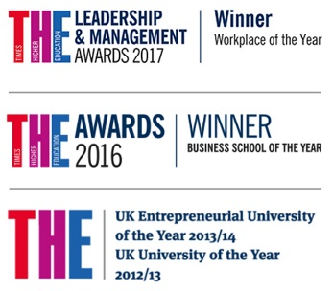
You also have the right to lodge a complaint against the University regarding data protection issues with the Information Commissioner’s Office (https://ico.org.uk/concerns/).
If you have any queries or concerns please contact:
scilt@strath.ac.uk or dataprotection@strath.ac.uk

The place of useful learning
The University of Strathclyde is a charitable body, registered in Scotland, number SC015263

Reflective questions for writing a commentary in English

Teachers may adapt the following questions to assist learners as they write commentaries. FE/HE students may also find these points useful to reflect upon in their commentaries.

Writing a commentary about your own work:

- Does your poem have a theme? How did you choose this? How have you represented this theme throughout your poem in terms of word choice and/or imagery?
- How did you choose the title of your poem?
- Does your poem related to a background topic or an area you have been studying?
- Did you choose to write from a particular perspective? Why?
- In your opinion, which words or lines in the poem are the most powerful? Why?
- Did you draw on any of your own personal experiences when writing the poem? How useful was this?
- Is there an overall message to your poem?
- What was it like writing a poem in another language/your mother tongue? How did it differ to writing in your own language/other languages? Would you do it again?

