- We will be using “jigsaw reading” to discover facts about World War Two

- It works well because there is a lot of information to read.
- Jigsaw reading breaks the information into manageable pieces!

- It also makes sure that everyone knows what information they are responsible for.
- How to complete a jigsaw reading activity:
1. The information needs to be divided into sections.
- 2. We are put into “home teams” and given a number. For example, 1, 2 or 3.
- 3. We meet in our “expert teams”. This means that all of the number 1 children will sit together and so on.
- 4. We read our own sections and work with our expert groups to discover information.
- 5. We return to our home teams and share what we have learnt.
- 6. There will always be a task in our home teams. Sometimes it might be to create a booklet or to make a poster. Once we even made Venn diagrams to sort out the information!

- Jigsaw reading makes learning new information exciting and manageable!
- 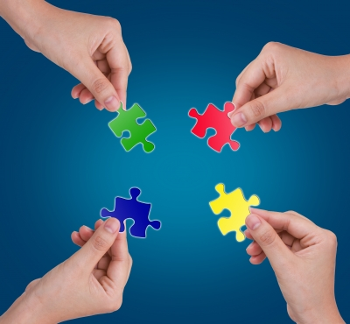

- What was World War 2?
In the 20th century there were two 'world wars'. Many countries were affected by the wars. The first war lasted from 1914 to 1918. Though it was fought mostly in Europe, people called it the First World War (World War 1).
The Second World War (World War 2) lasted from 1939 to 1945. It was fought in Europe, in Russia, North Africa and in Asia. 60 million people died in World War 2. About 40 million were civilians. Children as well as adults were affected by the war. This site will tell you what the war was like for children, mainly in Britain but in other countries too.

Who fought in the war?
World War 2 was fought between two groups of countries. On one side were the Axis Powers, including Germany, Italy and Japan. On the other side were the Allies. They included Britain, France, Australia, Canada, New Zealand, India, the Soviet Union, China and the United States of America.
Germany was ruled by Adolf Hitler and the Nazi Party. Hitler wanted Germany to control Europe. Japan wanted to control Asia and the Pacific. In 1937 Japan attacked China. In 1939 Germany invaded Poland. This is how World War 2 began.
Some countries did not join the war, but stayed neutral (on neither side). Spain, Sweden and Switzerland were neutral countries. So was Ireland, though many Irish people helped the Allies.

How did the war spread?
Britain and France went to war with Germany in September 1939.They wanted to help Poland after it was invaded, but they were too late. Poland was occupied by the Nazis. By the summer of 1940 they had conquered Holland, Belgium, France, Denmark and Norway. Enemy planes dropped bombs on cities in Britain. Allied ships were sunk by submarines.
In July 1940, German planes started bombing British coastal towns, defences and ships in the English Channel in order to gain control of the skies in the South of England. By mid-September 1940, after many battles, Germany postponed their planned land invasion of Britain as the RAF effectively fought off the German Luftwaffe. This period is known as The Battle of Britain.
Commonwealth nations, such as Canada and Australia, helped Britain. In 1941 the Soviet Union (Russia) was attacked by Germany. In 1941 America also joined the war, after Japan attacked the American naval base at Pearl Harbor in Hawaii. Use the timeline to find the important events and battles of the war.

How did the war end?
By 1943 the Allies were winning. One reason was that Allied factories were building thousands of tanks, ships and planes. In 1944, a huge Allied army crossed from Britain to liberate (free) France. Then Allied armies invaded Germany. By May 1945 the war in Europe was over.
The Pacific war went on until August 1945. There was fierce fighting on Pacific islands and big naval battles at sea. Finally, the Allies dropped atomic bombs on two Japanese cities, Hiroshima and Nagasaki. The damage was so terrible that Japan surrendered. World War 2 had ended.

