A Survivor
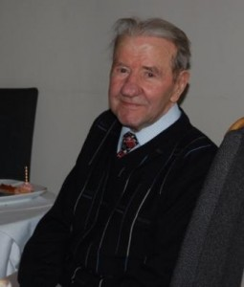
Zenon Sliwinski is one of the last living Second World War veterans in Scotland who served in the 1st Armoured Division under General Maczek. Mr Sliwinski lives in his adopted home of Glasgow. During the war he was based in Duns in the Scottish Borders and fought in the Normandy campaign.
His life before joining the 1st Armoured Division was one of exile and travel: a common experience of Polish soldiers who found themselves stationed in Scotland during the war.
He was living on his family’s farm in Eastern Poland, when the country was divided between Nazi Germany and the Soviet Union in 1939. He still recalls a winter’s day when he, his mother and two younger brothers were given two hours by the Russians to pack a few belongings before being marched to a station to be crammed in to a railway cattle wagon with other Polish exiles. There was a small stove in the middle of the three-tiered wagon and a hole in the floor for the toilet. They travelled in this wagon for well over a week. Mr Sliwinski remembers that one night his head froze to a bunk. On arrival in the Archangel area of Russia, they were transferred to sledges on which they travelled for another six days. The corpses of those who died on this journey were left by the side in the snow.
When Germany invaded Russia in 1941, the Poles became officially, though reluctantly, allies of the Russians and consequently Mr Sliwinski and his family were released from captivity. They travelled south by train and worked on a collective farm in the south Volga area.
From here, Mr Sliwinski travelled to Tehran and in the Spring of 1942 joined the Polish army. His mother and youngest brother were transferred to a peanut plantation in Kenya and his other brother went to Palestine. Given Mr Sliwinski’s knowledge of tractors and mechanics he was assigned to the 1st Armoured Division as a tank driver. The Scottish Borders area offered wide open spaces and terrain suitable for tank training during the war. Mr Sliwinski remembers testing a tank that could operate underwater.
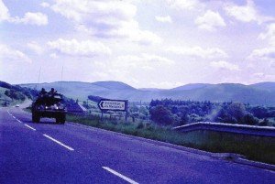
British Army vehicle in the Borders, c.1982
The 1st Armoured Division fought with great gallantry in Normandy in 1944 and during a particularly savage encounter with the enemy Mr Sliwinski was badly wounded. He was treated for his wounds in the field before being transferred to a military hospital in Liverpool.
At the war’s end, Mr Sliwinski decided to stay in the Britain and make Scotland his home. His other three family members returned to a Poland that was now a Communist totalitarian state.
He started visiting Poland in the 1970s but was initially treated with suspicion by Polish officials. With the demise of the Communist regime, travel became much easier. He now returns to his native country every year to visit his daughter who lives and works in Krakow.
To this day, he remains disappointed that political decisions at the time resulted in Polish combatants not participating in the London official victory parade of 1946; nor were they given the recognition they deserved after the war. The restoration of Mapa Scotland is one small act of gratitude and respect to the brave Poles, like Zenon Sliwinski, who fought alongside our nation during the Second World War.

