Step 1: Start by drawing the top portion of the head
Step 2: Sketch the nose
Step 3: Draw the top and rear of the Bear, add the rear foot.
Step 4: Add the ears and front legs and paw. Don’t forget to complete the rear leg.
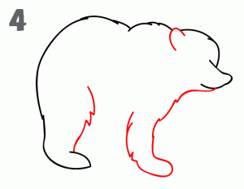
Step 5: Draw the additional 2 legs and paws.
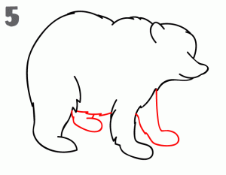
Step 6: Add the facial details and claws to each paw and you’re finished.
