Incredible Story of Polish Army Hero, Wojtek the Bear
By John Murray
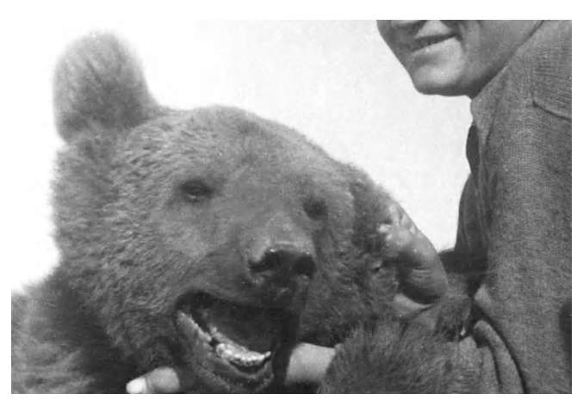

Wojtek with Polish soldier during WWII
He was the largest and most intimidating member of the Polish Army. Standing at 8ft, he led troops into parts of the frontline where even the most fierce soldier would not dare go, transporting vital artillery boxes to his grateful comrades.
Sure when it came to his downtime, he enjoyed himself, even sometimes having a beer! But in battle he was focused, reliable and, above all, incredibly brave. His name was Wojtek, and he was the Polish army’s secret weapon. His story has come to be important in recent years as a campaign was launched to honour this overlooked war hero. That successful campaign culminates on Saturday when a new statue of Wojtek is unveiled in Princes Street Gardens, ensuring the story of his extraordinary endeavours will live on for future generations. But how much do we really know about Wojtek?
His name – sometimes written as Voytek or Voychek – means “smiling warrior”. He was a Syrian brown bear with vicious claws, teeth like razors and the strength of several men. Those who knew him say his bravery and loyalty was almost as exceptional as his incredible gentleness. The story of how he was found by soldiers and raised to be one of their own to join their wartime struggle is amazing.
“I’m passionate about Wojtek’s story,” sculptor Alan Herriot told the Evening News at the beginning of the project.“Wojtek was an incredible creature. He was like one of the other soldiers. He became a national hero.
Wojtek’s story began by chance in Persia, now Iran, in 1942, where the Polish army, a group of soldiers released from Soviet slave camps in Serbia, were making the hard journey to join comrades fighting in Egypt and Italy. A young mountain shepherd boy had found the orphaned bear cub, and somewhere on the narrow mountain tracks running between Hamadan and Kangavar, the boy and the soldiers met. The Poles shared their food with the hungry lad and watched with interest the sudden movements coming from within his sack. The cub inside was desperately in need of care. For a few provisions, the boy traded his “pet” and set Wojtek on the road to becoming one of the world’s most famous creatures.
In 1944, troops were ordered to head for Italy to join the Allied advance on Rome. No animals were supposed to accompany them, so the Poles enrolled Wojtek as a soldier. They headed for Monte Cassino, where the by then 500lb bear astonished all by raising himself on to his hind legs and carrying boxes of live shells. It was such a remarkable sight that Wojtek became adopted as a symbol of the Polish fight, and the banner and buttons of the Transport Corps were redrawn to carry his image.
The Soviet occupation of Poland meant that at the end of the war the Polish soldiers and Wojtek ended up at Winfield Aerodrome on Sunwick Farm near Hutton in Berwickshire. Eventually the soldiers left, but Wojtek had to stay behind.
Interest in Wojtek was revived in 2007 following the Evening News retelling his story. At the time Archie Brown, who served with the 8th Army Signals HQ, recalled his meeting with the mighty Corporal Wojtek - and dispelled a few myths. Mr Brown, who has now sadly passed away, remembered: “Wherever he was, he brought a lot of joy to a lot of people. “But he wasn’t the drinking animal they are trying to make out . . . the beer bottles he drank from were filled with tea.”
Can you create some questions about this text? Remember your Bloom’s taxonomy!

