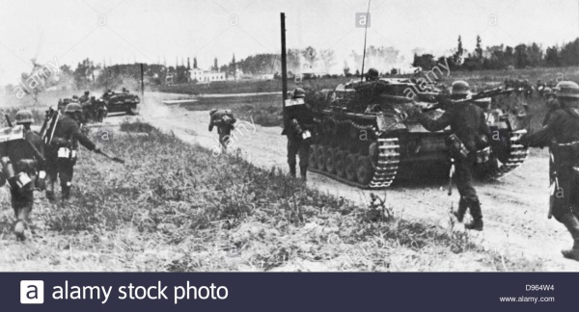

**1939: Germany invades Poland**

**German forces have invaded Poland and its planes have bombed Polish cities, including the capital, Warsaw.**

The attack comes without any warning or declaration of war.

Britain and France have mobilised their forces and are preparing to have a war with Germany.

Just before dawn today, the German army entered Polish territory on several fronts with a total of 1.5 million troops.

Soon afterwards German planes bombarded the cities. They have been making swift progress in destroying Polish defences which are heavily outnumbered in artillery, infantry and air power.

The cities of Katowice, Krakow, Tczew and Tunel were attacked with bombs. Air raids on Warsaw began at 0900 local time.

Communications to Katowice have been broken but earlier reports said German planes were coming over in squadrons of 50, every half-hour, and there have been many casualties.

Poznan was attacked from the main body of the German army and border towns occupied.

The 8th and 10th armies are moving north-east from Silesia towards Warsaw; and the 14th Army struck from Slovakia towards Krakow.

**Warning sent to Germany**

The Times newspaper reports that when the air raid sirens in the capital first sounded at 0600 inhabitants reacted calmly and some even ran out onto the streets to look up at the sky and had be driven back inside by air raid wardens.

The unprovoked attack follows yesterday's report on German radio that the border town of Gliwice had been raided by a group of Polish soldiers.

The Prime Minister, Neville Chamberlain, held a meeting with King George today in Downing Street.

Later this evening Mr Chamberlain told a packed House of Commons that British and French Ambassadors in Berlin had given German Foreign Minister Joachim von Ribbentrop an ultimatum.

He was to tell Berlin that unless the Nazis withdraw, Britain and France would fulfil its promise of support to Poland.

Von Ribbentrop said he would refer the message to Adolf Hitler.

US President Roosevelt of the United States has sent an appeal to the governments of Great Britain, France, Germany, Italy and Poland urging them to announce publicly their determination not to launch air attacks on civilians.

In reply the British and French governments say they intend to confine their bombing to military targets, so long as their opponents do the same.