France has Fallen! Great Britain on Full Alert! Polish Army to Reassemble in Scotland.
By John McCabe
10th May, 1940
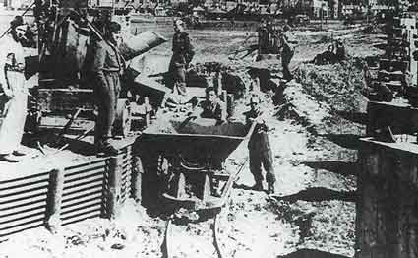

France fell yesterday to Germany and so Britain remains on full alert.
The Polish army, or the remnants of the Polish Army, made a desperate effort to save France along with the allied forces. However this was unsuccessful and now Europe is largely controlled by the Nazi party led by Adolf Hitler.
The Polish Army are due to arrive in Glasgow tomorrow. They will be known as 1st Polish Army Corps and will be under the command of General Marian Kukiel.
Their duties will be building coastal defences initially along the coast between Fife and Angus. They will also need to be re-trained on British equipment, which was is in desperate short supply.
The Island of Bute will become a Polish political detention centre to screen the troops for ‘fifth columnists’ or those who might damage the new strategies being developed by Sikorski and the Government in Exile.
Inverlochy Castle near Fort William (STS No.38) will be made available for the training of Special Forces (SF) known as the Cichociemni or The Silent and Unseen.
For some Polish soldiers their campaign odyssey started in Poland and took them via Hungary or Romania, France and North Africa. In Scotland they will be intensively re-trained and within two months, it is hoped that they will build a defensive perimeter to the north of Edinburgh supported by the Home Guard.
These plans are all dependent on the numbers of Polish soldiers that arrive in Glasgow. It is uncertain how many Poles were surviving in Vichy France and were able to escape.

