The Long Path to Freedom
15th July 1945
By Andrzej Gajos

Poland Liberated! Freedom for the country after four years of occupation!
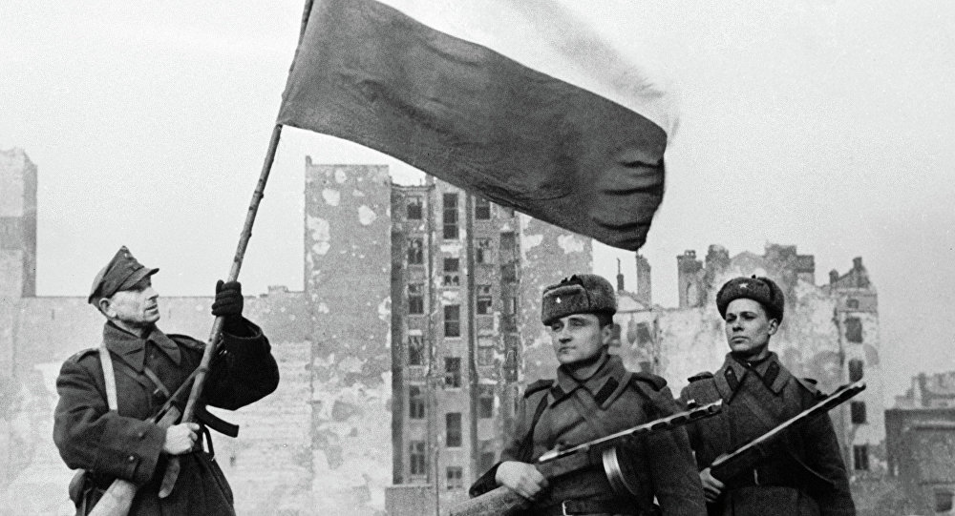

Poland has finally thrown off the German forces. People are celebrating on the streets after an abhorrent four years of occupation. The Polish Committee of National Liberation has established a Polish Government of National Unity and this government has officially been recognised by the British and U.S. governments today.

The war has devastated Poland from the initial invasion from the east by Nazi Germany and the west by the Soviets. Many Poles fled their homes and many others were forced into camps leaving family and friends behind.

Last Summer saw some more dramatic and explosive scenes initiated by the Anglo-American invasion of France in June. This enabled the Soviet armies to take advantage of the situation and inflict a series of devastating defeats on the Germans in the east.

Before the beginning of September the Soviet army, aided by contingents of Polish troops began operations on Polish territory. In August 1944 Polish resistance forces, known as the Home Army (Armia Krajowa), took control of Warsaw but were unsupported by the Soviets. This void of defence allowed the German forces to recapture the city and burn it to the ground. The remains were occupied by the Soviets who drove the Germans out in March. Such a victory allowed the formation of the Polish Government of National Unity, the new government of Poland.

